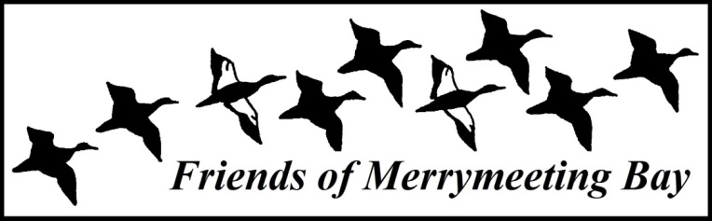
2014–2015
Speaker Series Bios

OCTOBER 8, 2014
Question 1: A Panel Discussion on Bear Hunting
Daryl DeJoy, Wildlife Alliance of Maine, and
Judy Camuso, Maine Inland Fisheries & Wildlife

This November, Maine voters will vote on Question 1, a referendum which proposes banning certain forms of bear hunting, including the use of traps, bait, and dogs. A similar referendum was narrowly defeated in 2004. Advocates for this year’s referendum argue it would end cruel and unfair practices, while opponents say the referendum is a public safety issue and keeping these practices assures bear control and minimizes attacks. For the first event of the 2014-2015 Speaker Series season, FOMB will host experts from both sides of the debate.

Daryl DeJoy is the Executive Director and Founder of the Wildlife Alliance of Maine (WAM). WAM is an organization whose primary reason for existing is to represent the non-consumptive interests in Maine who participate in wildlife watching and other related activities. WAM represents a very large constituency in Maine. Daryl has been a Registered Maine Guide for the past 23 years. For 10 years, he was a licensed Maine wildlife rehabilitator and is also a business owner, founding Penobscot Solar Design 26 years ago.

Judy Camuso is the Wildlife Division Director for Maine Inland Fisheries and Wildlife. She has worked for the department since 2007, starting as a regional biologist in southern Maine. Prior to that Judy worked as a biologist and the environmental center director for Maine Audubon for 11 years.

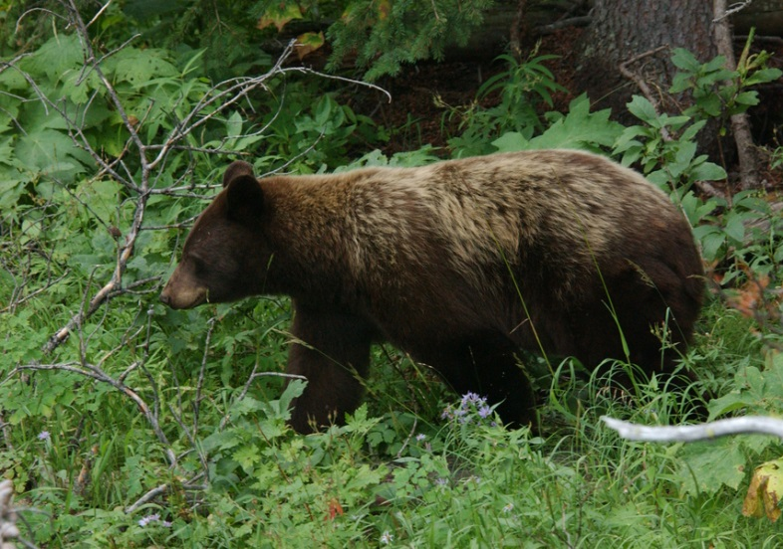
Black bear. Photo: Phil Meyers.

NOVEMBER 12, 2014
Searching For Historic Apples of Maine
John Bunker, Farmer, Author

Hundreds of local apple varieties long ago graced the orchards of Maine with fanciful names like Wolf River and Westfield Seek-No-Further. Where are they now? John Bunker has devoted much of his life to tracking down and preserving our agricultural heritage. Please join John for an evening of Maine apple exploration. Bring your apples and John will identify them for you.

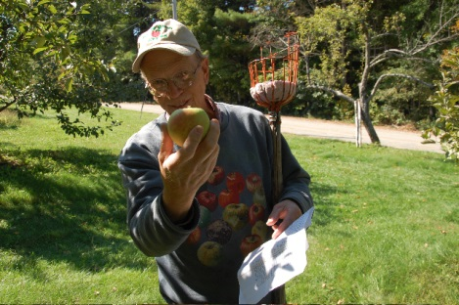
In pomological circles, John Bunker is considered the Apple Guru. Besides homesteading at Super Chilly Farm in Palermo, John leads talks, conducts apple pie tasting contests and various apple events, and travels extensively looking for rare apples. Many people refer to him as the “Apple Whisperer” and he is well-known for attracting considerable attention at the annual Common Ground Fair, where he maintains a booth for his company, Fedco Seeds. A longtime board member at Maine Organic Farmers and Growers Association (MOFGA, John was instrumental in the founding of the Maine Heritage Orchard at MOFGA’s headquarters in Unity and has been featured in national publications including Mother Jones, New York Times, and The Atlantic.
In 2007, John Bunker published Not Far From the Tree: A Brief History of the Apples and the Orchards of Palermo Maine, 1804-2004. This 190-page book, that chronicles two hundred years of apple farming in Palermo, was well received. It is filled with John’s wonderful illustrations, interesting anecdotes, maps, information about the uses of apples, and the history of several different varieties. The book is currently in its third printing.
DECEMBER 10, 2014
The Value of Honey Bee Pollination to Maine Agriculture
Tony Jadczak, Maine State Apiarist

In the last three decades, the bee industry has faced many challenges, including the introduction of two parasitic mite species, new strains of viral pathogens, microsporidia, and Africanized bees. Despite these problems, the commercial bee industry continues to meet the rigorous pollination demand of Maine’s blueberry industry.

Tony Jadczak has been the Maine State Apiarist since 1983. The position has both regulatory and extension functions. Prior to his employment with the Maine Department of Agriculture, Tony attended Rutgers University and worked there for four years upon graduation with a focus on blueberry and cranberry pollination.

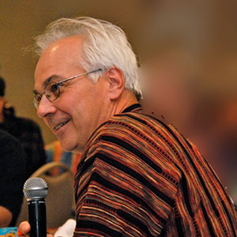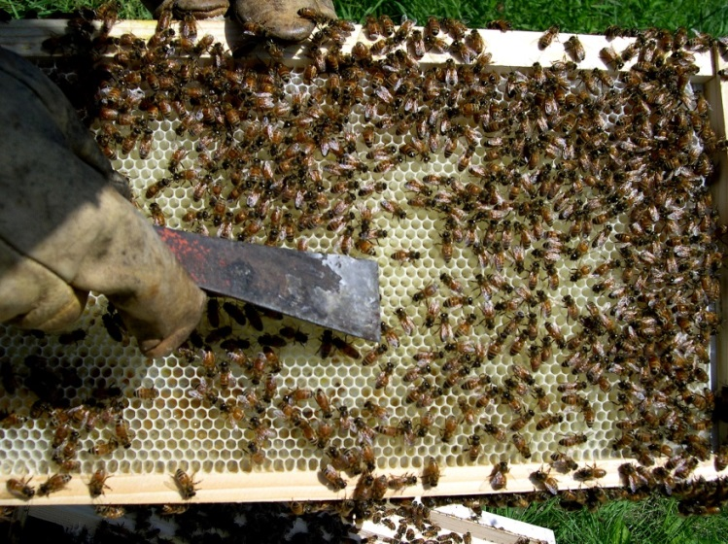
Photo: Maine State Beekeepers Association Photo: Kathleen McGee

JANUARY 14, 2015
Steve Powell's World of Wildlife: In Film and Photo
Jay Robbins, Historian

Steve Powell served as the local Zone Biologist for the Department of Inland Fisheries and Game (now IF&W) and eventually rose to oversee all the Wildlife Management Areas in Maine. He hunted with Governor Muskie and entertained thousands at sportsman's shows. A trapper and true outdoorsman, Steve lived in a world of wildlife. In 1968 Steve retired from State service to live out the rest of his life on Green Point Farm in Dresden.

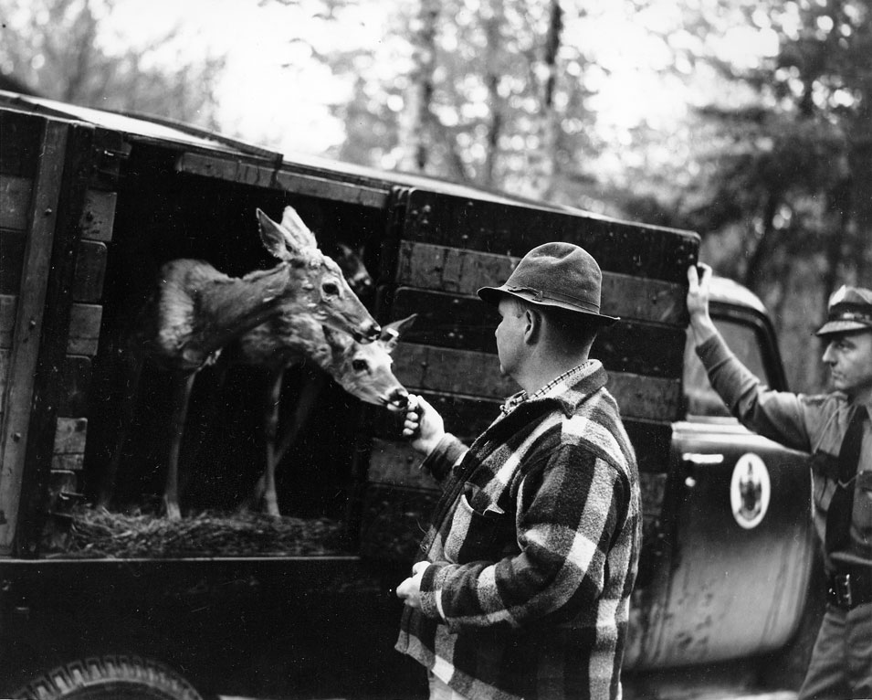
Thankfully, Steve left behind over 11 hours of silent film and over 600 still images documenting his variety of experiences. His nephew Bob Gleason turned these films, photos, and boxes of files over to Dr. Charles Burden and Jay Robbins in 2012 for their preservation and eventual placement with the State Archives. The films are now being fully conserved and digitized, the photos scanned, and the files archived. Come enjoy some of the gems from this valuable pictorial collection.

Place-based historian Jay Robbins of Richmond will narrate this presentation. He is Bowdoin College's first Environmental Studies graduate (1973), is a former Richmond Town Manager, has served FOMB on the Steering Committee (1995-2000) and as an archaeologist for Bay Day since 1999, is a frequent lecturer on various local history topics, and is a former Executive Director of the Lincoln County Historical Association. Jay currently serves as President of the Friends of Swan Island and also of the Arnold Expedition Historical Society.

FEBRUARY 11, 2015
Chimney Farm: Words from the Watershed
Gary Lawless, Poet

Chimney Farm on Damariscotta Lake was the Maine home of writers Henry Beston, Elizabeth Coatsworth, and Kate Beston Barnes. As Kate Barnes said, “the main crop of the farm was words.” Much of that writing was influenced by the natural world around the farm, which is now protected by the Damariscotta Lake Watershed Association. Speaker Gary Lawless has lived as caretaker at the farm since 1986, and will talk about and read from the words of these writers celebrating the natural world.
Gary Lawless is a poet, bookstore owner, book editor, and publisher, born in Belfast and living now in Nobleboro. He is co-owner of Gulf of Maine Books in Brunswick (with Beth Leonard) and owner of the publishing company Blackberry Books in Nobleboro. He is an associate professor of literature at Bates College in Lewiston, where he teaches courses in creative writing and environmental literature. Lawless has been poet-in-residence for the town of Sitka, Alaska, and for the National Park Service at Isle Royale National Park at Lake Superior, in 1998, and he taught creative writing for five years in MSAD 75's adult education program.
After graduating from Colby College in 1973, Lawless left Maine to spend a year in California studying with poet Gary Snyder. When Lawless returned to Maine, he brought the idea of the budding bioregional movement with him. In 1987, he organized a Gulf of Maine Bioregional Congress, bringing together a diverse group of back-to-the-land and "green" folks from across northern New England and eastern Canada for a four-day series of workshops and presentations.
Lawless has written and edited several books, all with the common theme of ecological integrity and spirit.

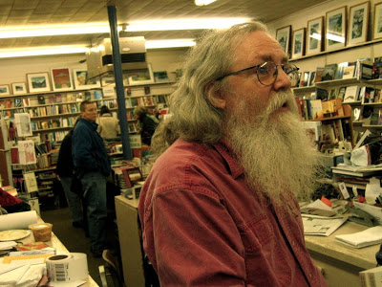
Photo: Richard Fleming.

MARCH 11, 2015
Big Night: Rise of the Frogs & Salamanders
Dan Nein, Wildlife Biologist, Stantec

Spring rains not only bring spring flowers. They also trigger the annual event known as “Big Night” when, under the cover of darkness, amphibians leave their subterranean boroughs and winter forest habitat for seasonal fishless wetlands in search of breeding partners. This presentation will provide a natural history overview of the event and species involved, including species identification and the environmental cues triggering their overland migrations. Tips and information will also be shared on how people can independently observe or become involved with state-organized citizen science efforts to locally monitor Big Night. A brief overview of current state regulations protecting seasonal wetland breeding habitat, known as vernal pools, will also be presented.

Dan Nein grew up in Maine with an appreciation and love for the outdoors and natural world. Dan’s passion began at an early age exploring wetlands and forests near his childhood home in southern Maine and family camp in the Moosehead Lake Region. Dan attended the University of Maine–Orono and graduated with a B.S. in Wildlife Ecology. As an undergraduate he was active with the Student Chapter of The Wildlife Society and assisted graduate students with their projects studying black terns, wood turtles, forest biodiversity, and American woodcock.

Dan is currently a Certified Wildlife Biologist (as recognized by The Wildlife Society) and Program Manager with Stantec Consulting Services based in Topsham. Dan currently works on variety of natural resource based projects, providing regulatory guidance, resource characterization, and design recommendations for avoidance, minimization, and mitigation of project impacts.

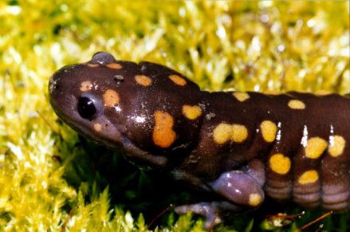
Spotted salamander. Photo: Paul Kosnik.

APRIL 8, 2015
Sea Run Alewife Restoration
Frank Richards, Webber Pond Association

Webber Pond, located in Vassalboro and draining into the Kennebec River, is home to a very successful alewife restoration project. Frank Richards, President of the Webber Pond Association, will talk about the details and politics of that project and why the outcome was so different than the St. Croix. Frank will also speak about alewives in Merrymeeting Bay, encouraging people to support small nonprofits to implement useful community-supported projects.

Frank Richards is a retired statistical programmer and analyst for a state agency interested in politics and administration as well as environmental issues. He’s been the President of the Webber Pond Association since 2001 and played a critical role in restoring that system. He grew up in New Hampshire and has lived in Maine since 1984. In his free time, Frank can be found in a canoe exploring remote areas like the Arctic, James Bay, and most of the rivers in Maine. He is retired and has written two books: A Guide to Wilderness Canoe Fishing and An Introduction to Ice Fishing.

MAY 13, 2015
Unseen but Everywhere: Plankton & Particles!
Harry Nelson, Fluid Imaging Technologies

In the summer of 2014, FOMB took an opportunity to probe the unseen but prolific phytoplankton (plant) and zooplankton (animal) community in Merrymeeting Bay. With cooperation from Fluid Imaging Technologies (FIT) in Scarborough we utilized their FlowCAM, the first automated particle analysis instrument using digital imaging, to measure the size and shape of microscopic life in Bay water samples. This final presentation of the 2014-2015 series will be led by Harry Nelson from FIT, who will provide information on how the FlowCAM was developed and the numerous industries it serves. Harry will then share images and findings from our 2014 probe and explain the importance of plankton to the global ecosystem.
Harry Nelson has over 25 years of experience in manufacturing and sales with numerous high-tech firms. After graduating from Colby College with a B.A. in Environmental Studies he went on to receive his M.B.A from University of New Hampshire. For the past nine years, Harry has worked at Fluid Imaging where he is responsible for worldwide sales and product development of FlowCAM.
Fluid Imaging Technologies, Inc. manufactures industry-leading particle analysis instrumentation based on digital imaging technology. Their flagship product, the FlowCAM, is the first automated particle analysis instrument to use digital imaging for measuring size and shape of microscopic particles in a fluid medium. With applications in oceanographic research, municipal water, biopharmaceutical formulations, chemicals, oil and gas, biofuels and many other markets, Fluid Imaging Technologies is a leader in imaging particle analysis.

The FlowCAM is in use by the U.S. EPA, FDA, and Scripps Institution of Oceanography, among hundreds of other organizations in over 40 countries and on every continent.
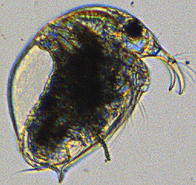
Photo: Fluid Imaging Technologies

